**20BCS042 | MOHD ADIL**

**ASSIGNMENT 2**

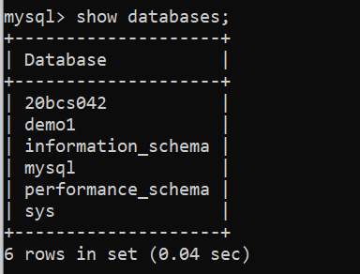Viewing The Existing Databases, Switching to the Desired Database:

Using 20BCS042 database and CREATING tables:

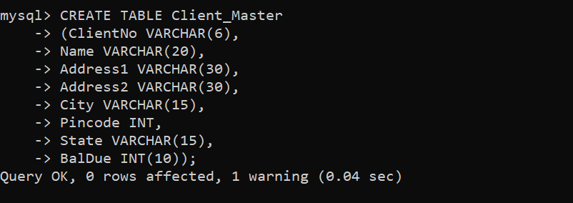 **Creating Client Master Table:**

**Creating Product Master Table:**

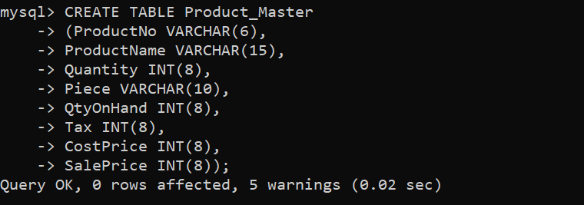

**Inserting Values in Client Master Table and Product Master Table:**

mysql> INSERT INTO Client_Master VALUES

-> ('C00001', 'Ivan Bayross', 'Address1', 'Address2', 'Mumbai', 400001, 'Maharashtra', 15000),

-> ('C00002', 'Mamta Muzumdar', 'Address1', 'Address2', 'Madras', 780001, 'Tamil Nadu', 0),

-> ('C00003', 'Chhaya Bankar', 'Address1', 'Address2', 'Mumbai', 400057, 'Maharashtra', 5000),

-> ('C00004', 'Ashwni Joshi', 'Address1', 'Address2', 'Bangalore', 560001, 'Karnataka', 0),

-> ('C00005', 'Hansei Colaco', 'Address2', 'Address2', 'Mumbai', 400060, 'Maharashtra', 2000),

-> ('C00006', 'Deepak Sharma', 'Address1', 'Address2', 'Mangalore', 560050, 'Karnataka', 0);

Query OK, 6 rows affected (0.01 sec)

Records: 6 Duplicates: 0 Warnings: 0

mysql> INSERT INTO Product_Master VALUES

-> ('P00001', 'T-Shirt’, 5, 'Piece', 200, 50, 350, 250),

-> ('P0345', 'Shirts', 6, 'Piece', 150, 50, 500, 350),

-> ('P06734', 'Cotton Jeans', 5, 'Piece', 100, 20, 600, 450),

-> ('P07865', 'Jeans', 5, 'Piece', 100, 20, 750, 500),

-> ('P07885', 'Trousers', 2, 'Piece', 150, 50, 850, 550),

-> ('P07868', 'Pull Overs', 2, 'Piece', 150, 50, 850, 550),

-> ('P07868', 'Denim Shirts', 4, 'Piece', 100, 40, 350, 250),

-> ('P07898', 'Lycra Tops', 5, 'Piece', 70, 30, 300, 175),

-> ('P07868', 'Skirts', 5, 'Piece', 75, 30, 450, 300);

Query OK, 9 rows affected (0.01 sec)

Records: 9 Duplicates: 0 Warnings: 0

**Exercise :3 Exercise on retrieving Data**

1. **Find Out the Name of all the Clients.**

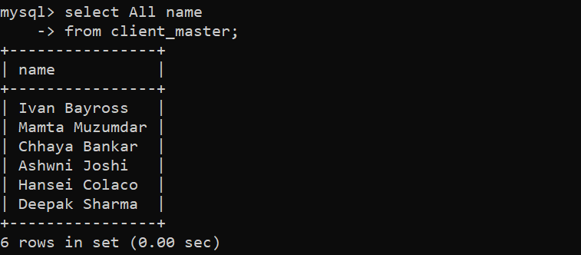

1. **Retrieve the entire contents of the Client Master Table:**

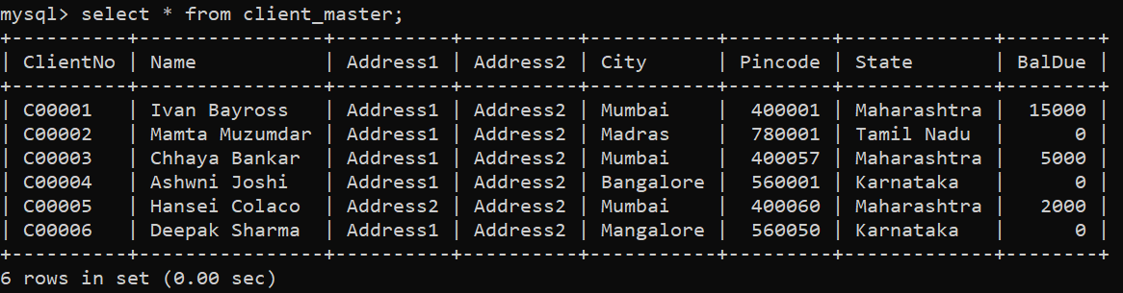

1. **Retrieve the list of names, city and the state of all the clients.**

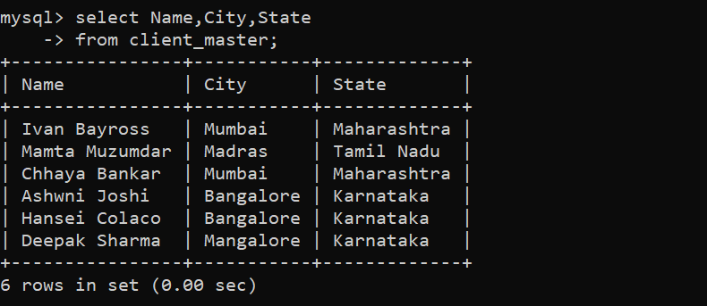

1. **List the various products available from the Product Master Table:**

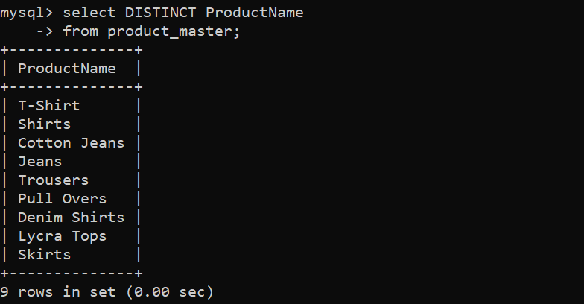

1. **List all clients who live in Mumbai:**

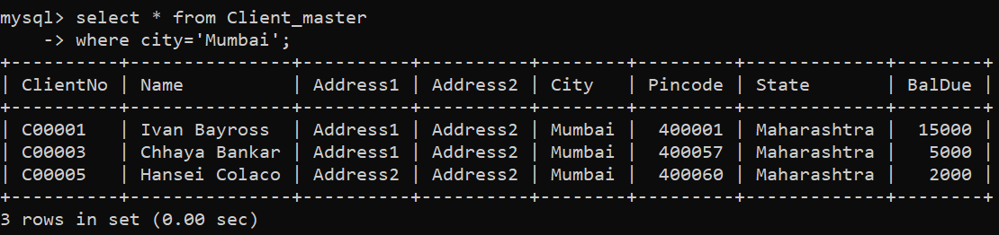

**Exercise 4: Exercise on updating the records in the table:**

1. **Change the city of Client No ‘C00005’ to ‘Bangalore’.**

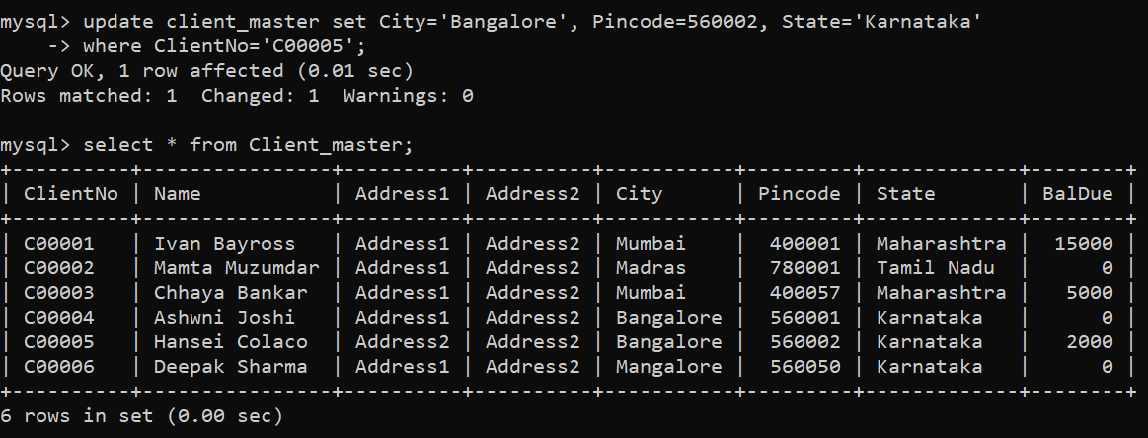

1. 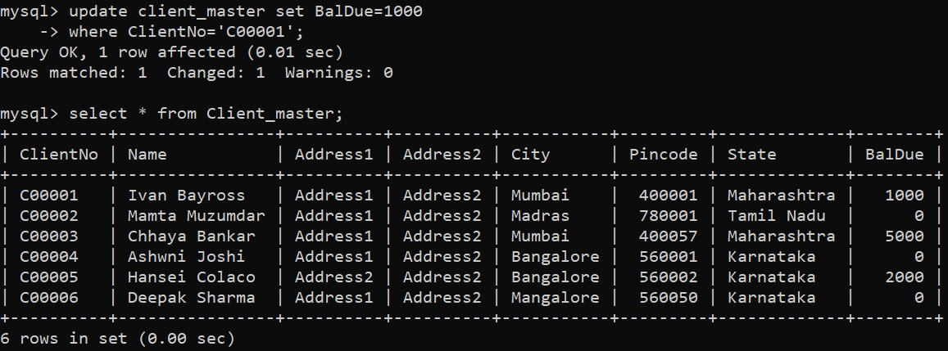**Change the Bal Due of Client No C0001 to Rs. 1000.**

1. **Change the Cost Price of Trousers to Rs. 950.**

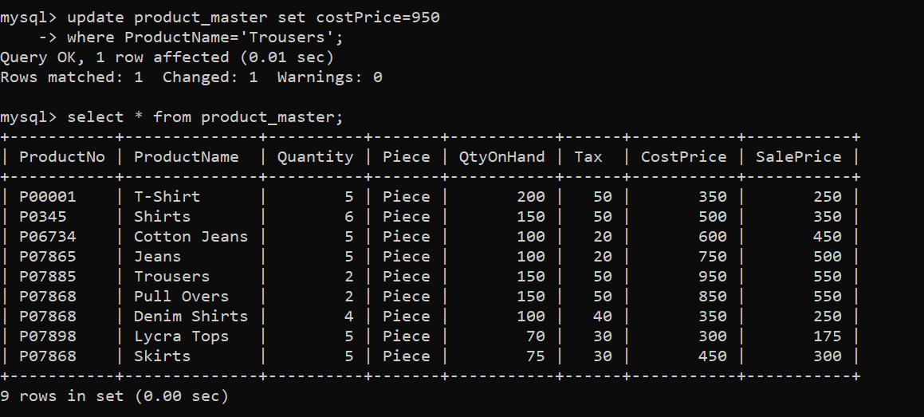

**Exercise 5: Deleting the records in the table.**

1. **Delete all products from Product_Master where the QtyOnHand is equal to 100.**

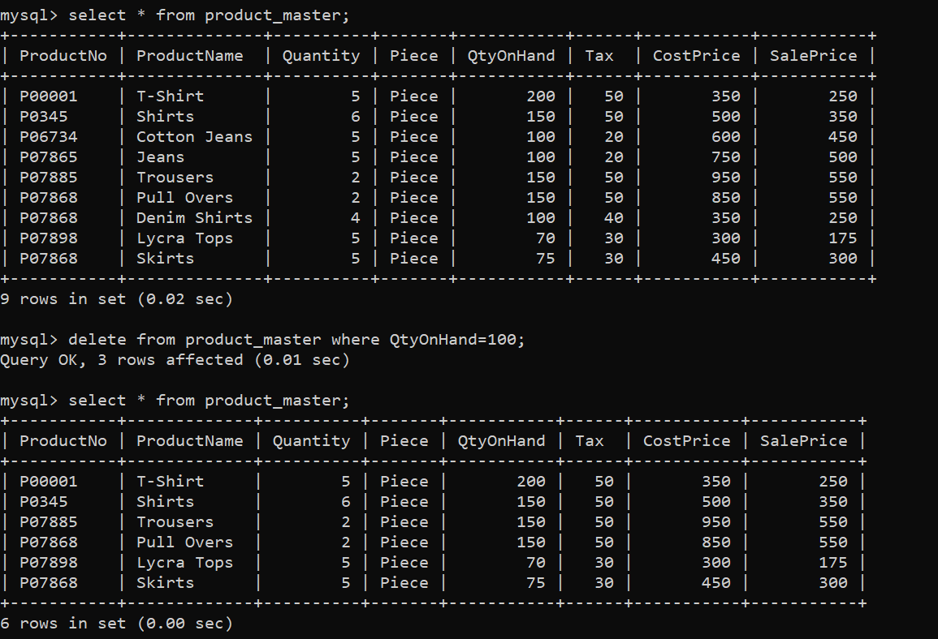

1. **Delete from Client where the column state =’Maharashtra’.**

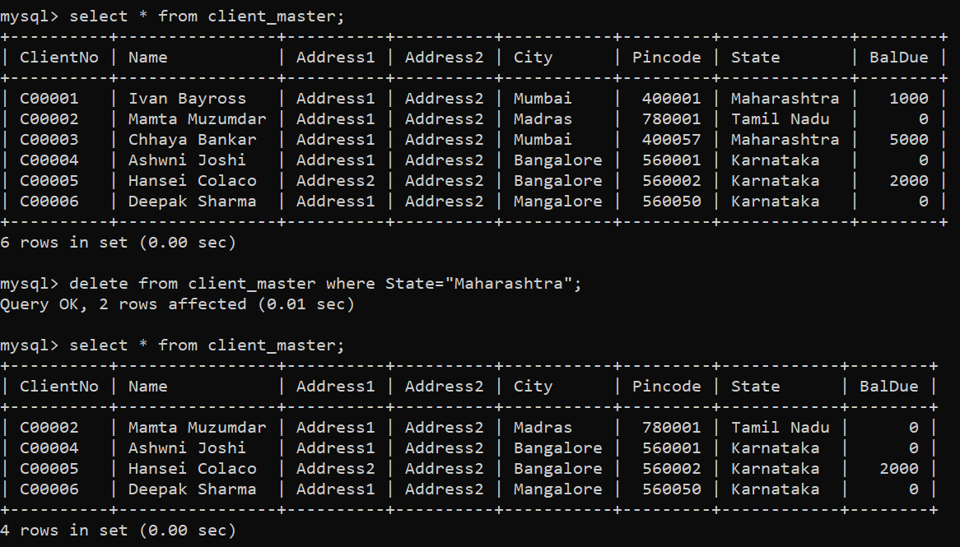

**Exercise 6: Altering the table structure.**

1. **Add a column called ‘Telephone’ of data type ‘number’ and size ‘10’ to the Client_Master table.**

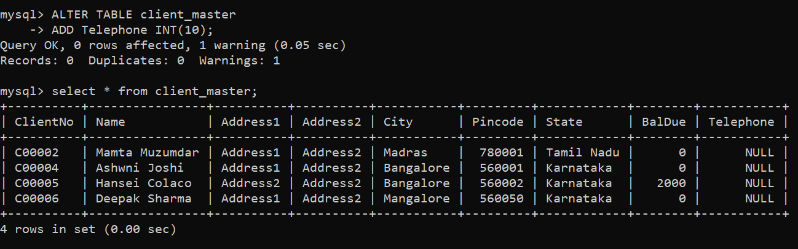

1. **Change the size of Sale Price column Product_Master to 10,2.**

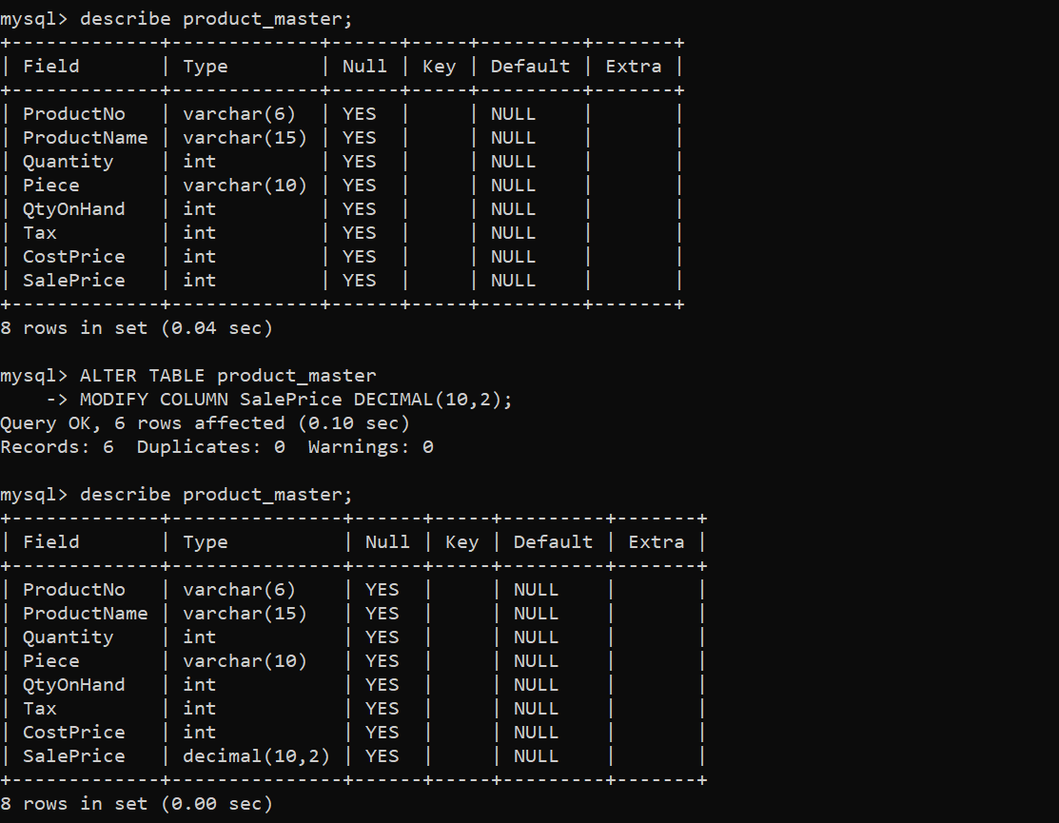

**Exercise 7: Exercise on deleting the table structure.**

1. **Destroy table Client_Master along with its data.**

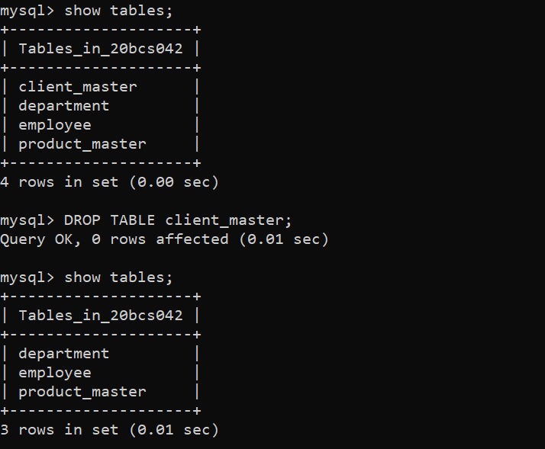

Thank You